
Department of Computer and Communication Engineering

LAB REPORT
Experiment No : 02
Experiment Name : Draw Different Shapes in Computer Graphics

Course Title : Computer Animation and Game Development Sessional
Course Code : CCE - 3606

Submitted By
Name : Kazi Sultana Sunehra
ID No : E231413
Semester : 5th
Section : 5AF

Date of Experiment: 22. 09. 2025
Remark
Date of Submission: 29. 09. 2025

Submitted To
Md. Warid Bin Azad
Adjunct Faculty, Dept. of CCE, IIUC

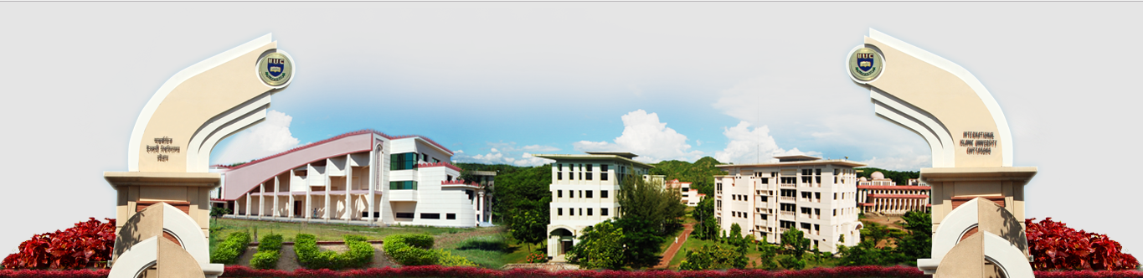
Experiment No: 02

Experiment Name: Draw Different Shapes in Computer Graphics

Lab Task – 01: Draw Three Different Lines

- One horizontal line
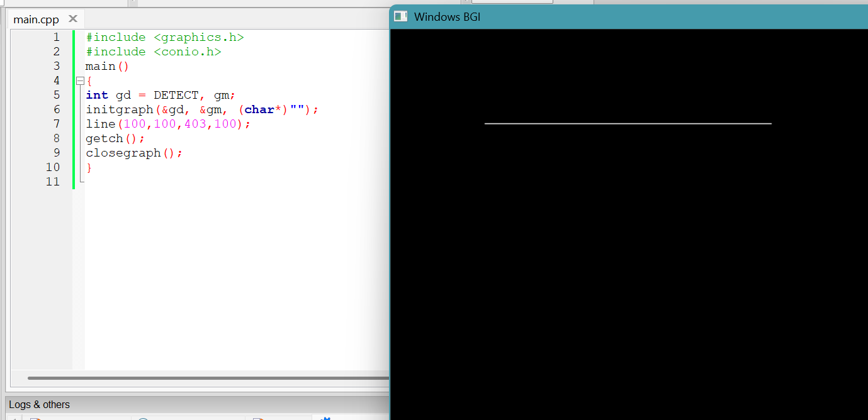
Figure – 1.1: Source Code and Output for Lab Task – 01(i)

- One vertical line
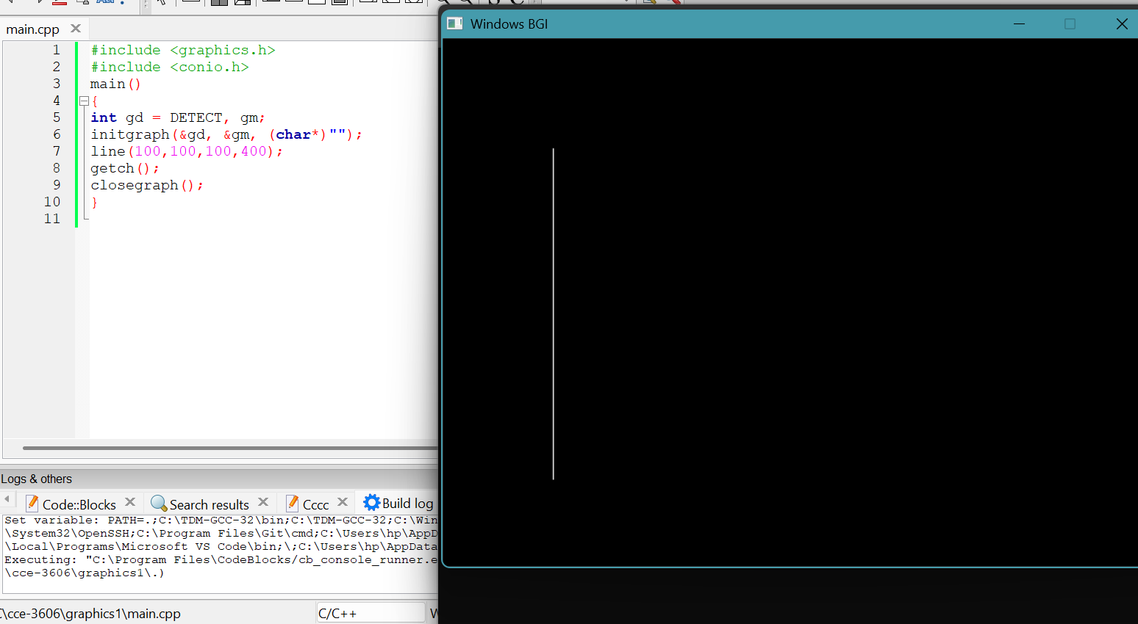
Figure – 1.2: Source Code and Output for Lab Task – 01(ii)
- One diagonal line
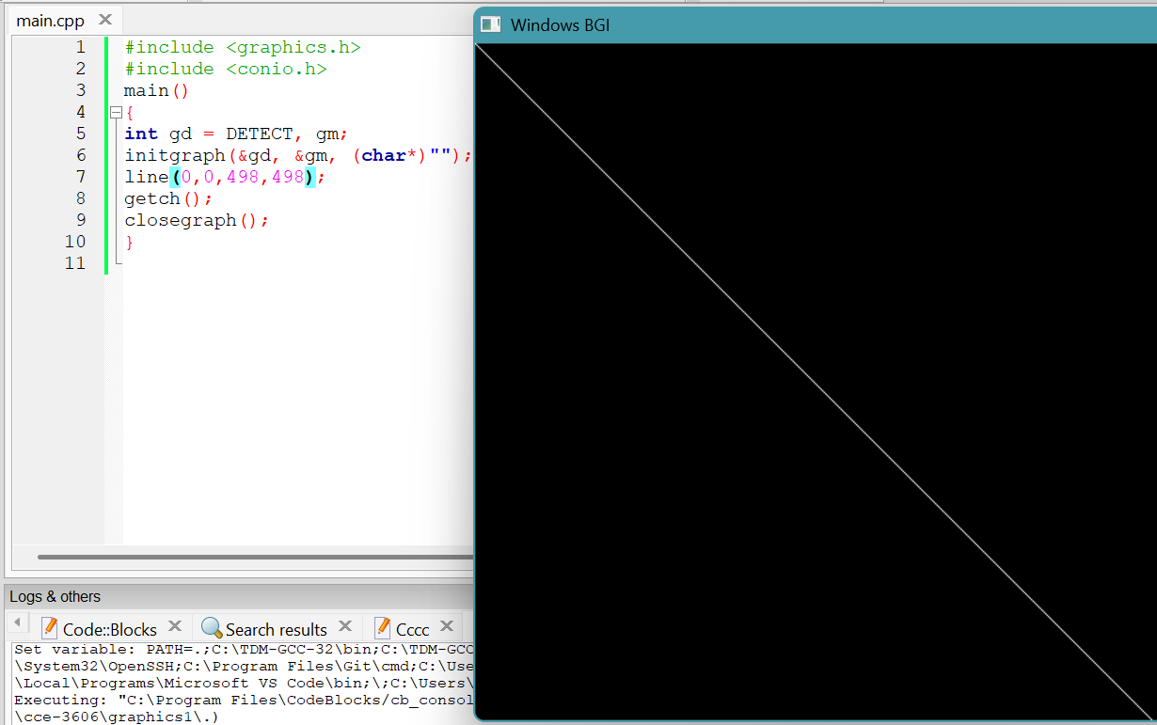
Figure – 1.3: Source Code and Output for Lab Task – 01(iii)

Lab Task – 02: Draw Two Circles

- One small circle
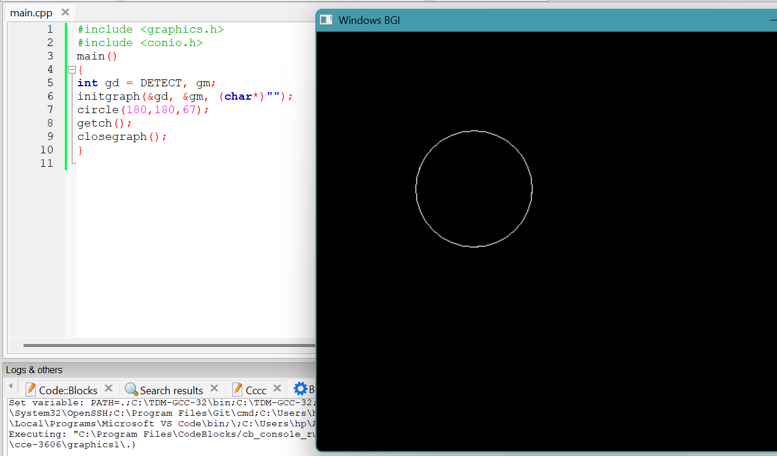
Figure – 2.1: Source Code and Output for Lab Task – 02(i)

- One large circle
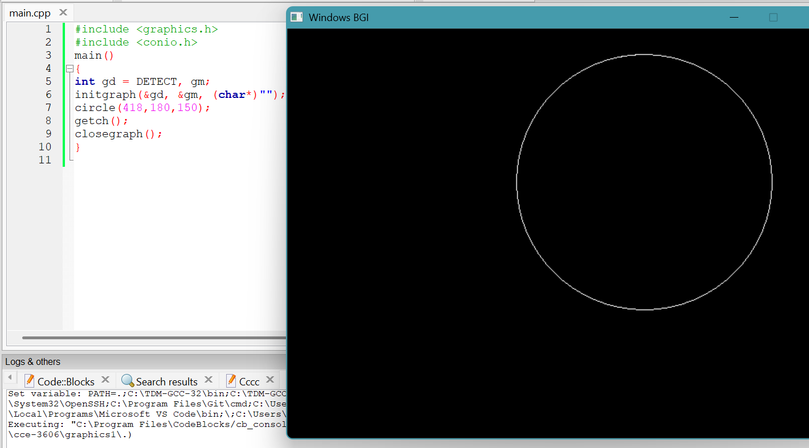
Figure – 2.2: Source Code and Output for Lab Task – 02(ii)

- Place the circles side by side
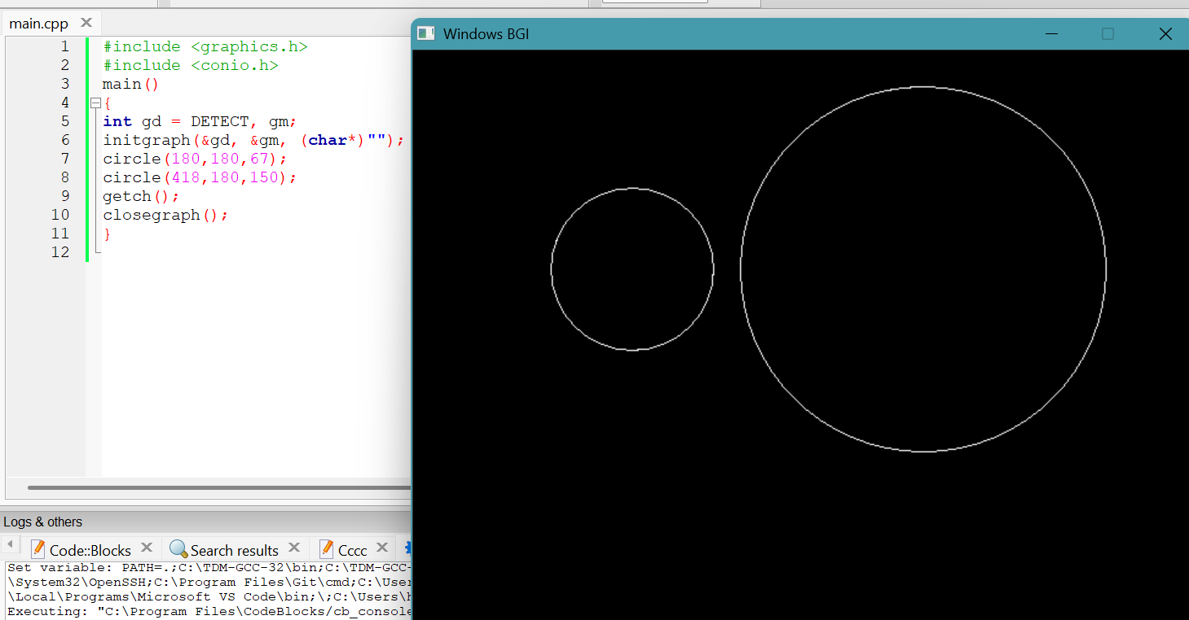
Figure – 2.3: Source Code and Output for Lab Task – 02(iii)

Lab Task – 03: Draw Two Rectangles

- Draw one rectangle inside another (nested rectangles)
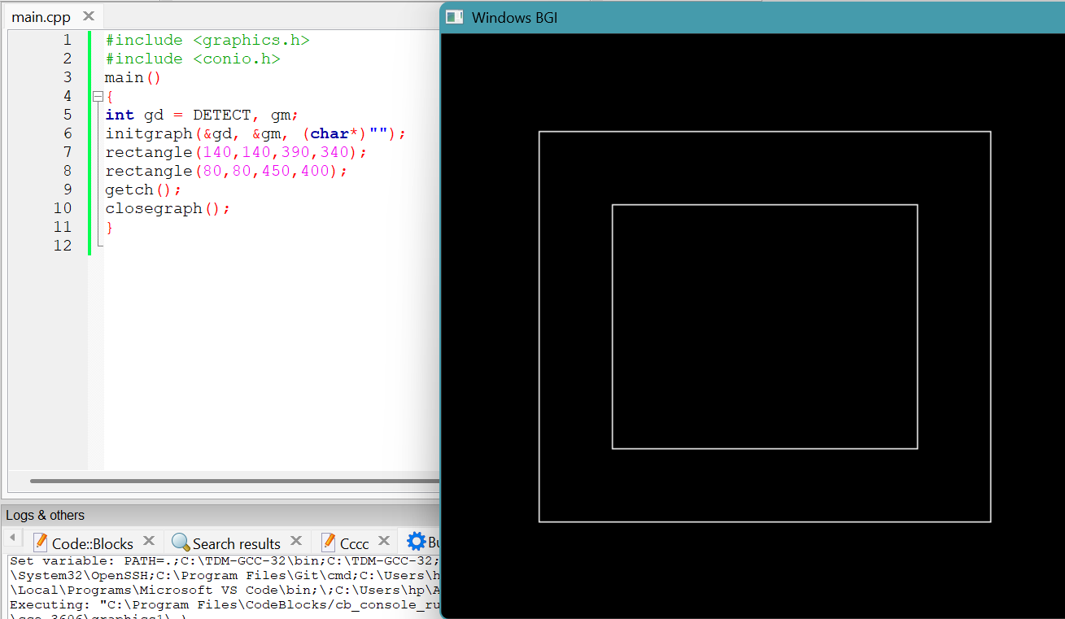
Figure – 3.1: Source Code and Output for Lab Task – 03

Lab Task – 04: Draw a Triangle

- Using three line() functions to connect three vertices
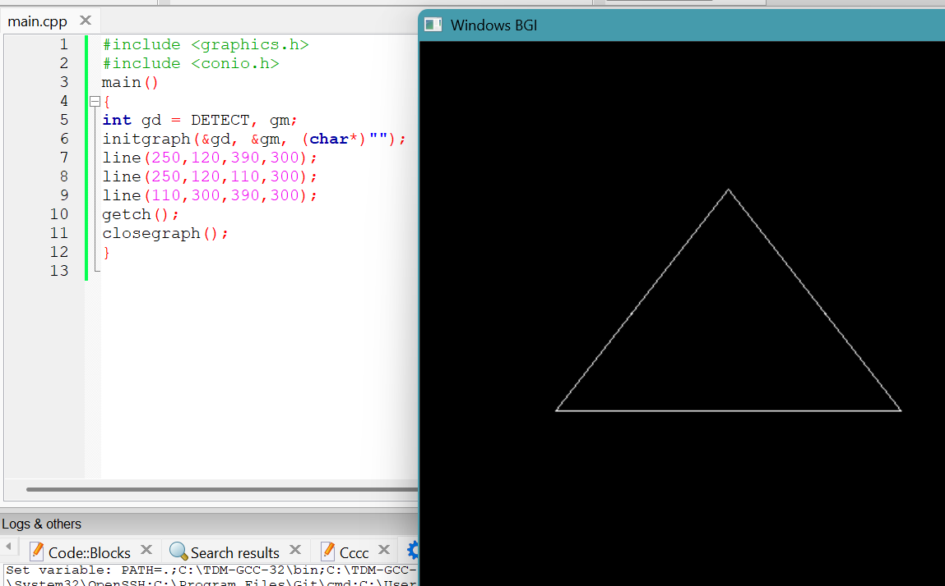
Figure – 4.1: Source Code and Output for Lab Task – 04

Lab Task – 05: Draw the Palestine Flag
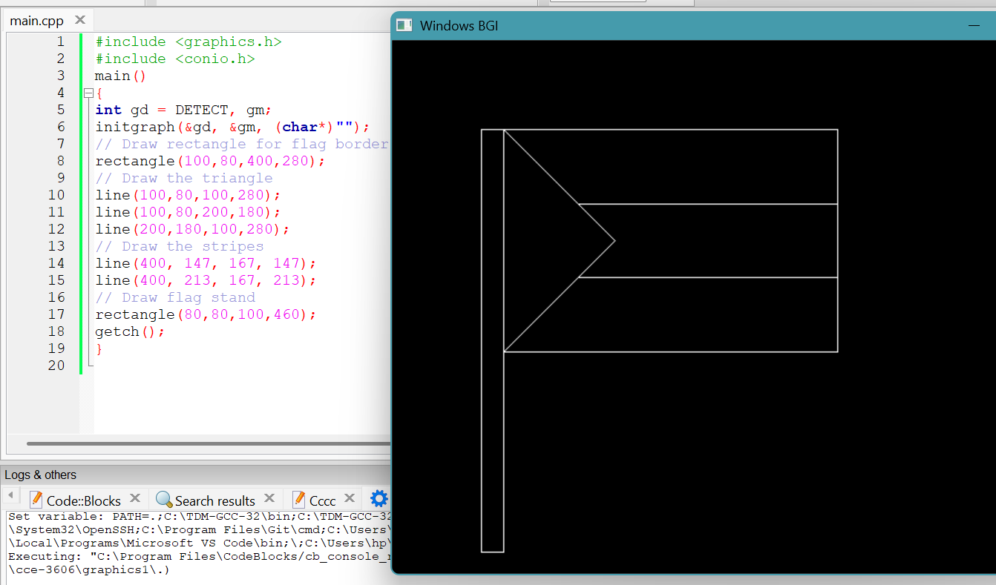
Figure – 5.1: Source Code and Output for Lab Task – 05

